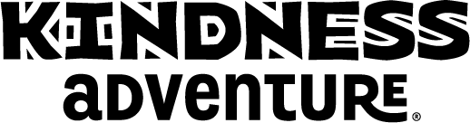 NEWS RELEASE

Kindness Adventure®
(City of School, State) – The Kindness Adventure school assembly, presented by All for KIDZ®, will visit the staff and students from (name of school) on (day and date of show). The performance will inspire everyone to be kind-hearted and caring to others at school, at home, in their community and even in Kenya!
The character education organization All for KIDZ® presents live performances to schools in all 50 US states, Canada, the United Kingdom, Australia and New Zealand. Working with schools since 1989, they have seen more than 35 million students and will visit more than 6,000 schools this year. Their elementary school assemblies support and enhance school initiatives for developing strong character, establishing positive behavior, and improving school climate.
The Kindness Adventure assembly utilizes storytelling, music, magic, audience participation and interactive videos to tell the story of a cartoon character named NED. The adventure begins when NED and the performer accept an invitation to visit the country of Kenya. Although NED is initially uncertain about the cultural differences, he quickly learns he has something powerful in common with the kids in Kenya...a smile and a kind heart.
Throughout the show, the performer highlights the satisfaction that takes place when children show kindness and acceptance towards those who are perceived as “different” from themselves. The themes developed in the performance aim to prevent mistreatments that can occur at school, including bullying. After the performance, All for KIDZ provides free online lessons and resources for teachers to use to reinforce these positive messages with their students throughout the year.
Schools that host the Kindness Adventure use All for KIDZ’s Pay-It-Forward® payment method, which allows the program to visit schools that do not have a budget for assemblies.
For more information about the Kindness Adventure visit www.KindnessAdventure.com.
###
For further information about All for KIDZ contact Lois Hickman at 877-872-9696 x156.

